**Day 12 Assignment**

**1. Generics and Type Safety Create a generic Pair class that holds two objects of different types, and write a method to return a reversed version of the pair.**

|  |
| --- |
|  |
| /* |
| Generics and Type Safety Create a generic Pair class that holds two objects of different types, |
| and write a method to return a reversed version of the pair. |
| */ |
|  |
| class Pair<T, G> { |
| private T obj1; |
| private G obj2; |
|  |
| Pair(T obj1, G obj2) { |
| this.obj1 = obj1; |
| this.obj2 = obj2; |
| } |
|  |
| @Override |
| public String toString() { |
| return "(" + |
| obj1.getClass().getName() + |
| " : " + |
| obj1.toString() + |
| " , " + |
| obj2.getClass().getName() + |
| " : " + |
| obj2.toString() + |
| ")"; |
| } |
|  |
| public Pair<G, T> reversedPair() { |
| return new Pair(obj2, obj1); |
| } |
| } |
|  |
| public class Assignment_1 { |
| public static void main(String[] args) { |
| System.*out*.println("Creating a type safe class called Pair"); |
| Pair<String, Integer> pair = new Pair<String, Integer>("Hello", 1234); |
| System.*out*.println(pair); |
| System.*out*.println("Reversed Pair"); |
| Pair<Integer, String> revPair = pair.reversedPair(); |
| System.*out*.println(revPair); |
|  |
| } |
| } |

|  |
| --- |
| package m5_core_java_programming.day_12; |
|  |
| /* |
| Implement a generic method that swaps the positions of two elements in an |
| array, |
| regardless of their type, and demonstrate its usage with different object |
| types. |
| */ |
|  |
| import java.util.Scanner; |
|  |
| class Arr { |
| private Object[] arr; |
| private final int size; |
| private int curr; |
|  |
| Arr(int size) { |
| this.arr = new Object[size]; |
| this.size = size; |
| this.curr = 0; |
| } |
| public int size() { |
| return this.size; |
| } |
|  |
| public void add(Object obj) { |
| if (this.curr < this.size) { |

# Output

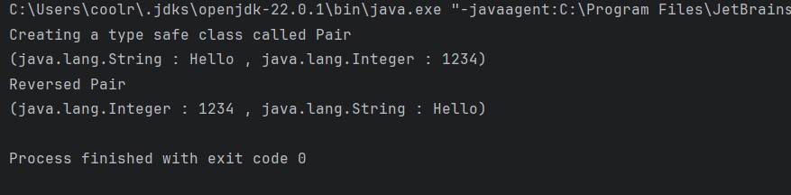

**2. Implement a generic method that swaps the positions of two elements in an array, regardless of their type, and demonstrate its usage with different object types.**

|  |
| --- |
| this.arr[this.curr] = obj; |
| this.curr++; |
| } else { |
| System.*out*.println("Array is filled"); |
| } |
| } |
|  |
| public void replace(int a, int b) { |
| if (a < 0 || a >= this.size || b < 0 || b >= this.size || a == b || |
| this.curr < this.size) { |
| System.*out*.println("Please fill the array first"); |
| } else { |
| Object temp = this.arr[a]; |
| this.arr[a] = this.arr[b]; |
| this.arr[b] = temp; |
| } |
| } |
|  |
| @Override  public String toString() { |
| if (this.curr < this.size) { |
| System.*out*.println("Please fill the array first"); |
| return "Please fill the array first."; |
| } else { |
| String string = "( "; |
| for (Object x : this.arr) { |
| string += " " + x.toString(); |
| } |
| string += " )"; |
| return string; |
| } |
| } |
| } |
|  |
| public class Assignment_2 { |
| public static void main(String[] args) { |
| Scanner scan = new Scanner(System.*in*); |
| System.*out*.println("Enter the size of the array : "); |
| int n = scan.nextInt(); |
| System.*out*.println("Enter the Items"); |
| Arr arr = new Arr(n); |
| for (int i = 0; i < n; i++) { |
| System.*out*.println("Choose from any wrapper class type :"); |
| System.*out*.println("1. Integer"); |
| System.*out*.println("2. Long"); |
| System.*out*.println("3. Byte"); |
| System.*out*.println("4. Short"); |
| System.*out*.println("5. Double"); |
| System.*out*.println("6. Float"); |

|  |
| --- |
| System.*out*.println("7. String"); |
| int option = scan.nextInt(); |
| switch (option) { |
| case 1: { |
| System.*out*.println("Enter item : "); |
| arr.add(scan.nextInt()); |
| break; |
| } |
| case 2: { |
| System.*out*.println("Enter item : "); |
| arr.add(scan.nextLong()); |
| break; |
| } |
| case 3: { |
| System.*out*.println("Enter item : "); |
| arr.add(scan.nextByte()); |
| break; |
| } |
| case 4: {  System.*out*.println("Enter item : "); |
| arr.add(scan.nextShort()); |
| break; |
| } |
| case 5: { |
| System.*out*.println("Enter item : "); |
| arr.add(scan.nextDouble()); |
| break; |
| } |
| case 6: { |
| System.*out*.println("Enter item : "); |
| arr.add(scan.nextFloat()); |
| break; |
| } |
| case 7: { |
| System.*out*.println("Enter item : "); |
| arr.add(scan.next()); |
| break; |
| } |
| default: { |
| System.*out*.println("Wrong choice"); |
| i--; |
| break; |
| } |
| } |
| } |
|  |
| System.*out*.println(arr); |
|  |
| System.*out*.println("Enter indexes to swap item : "); |
| System.*out*.println("Enter first index : "); |
| int a = scan.nextInt(); |
| System.*out*.println("Enter second index : "); |
| int b = scan.nextInt(); |
| arr.replace(a, b); |
| System.*out*.println("After swapping :"); |
| System.*out*.println(arr); |
| } |
| } |

# Output

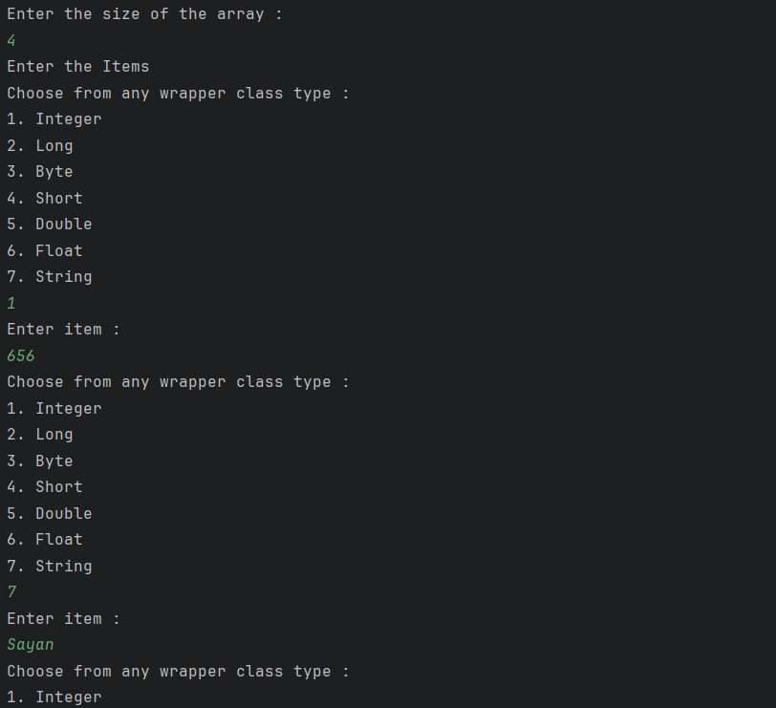

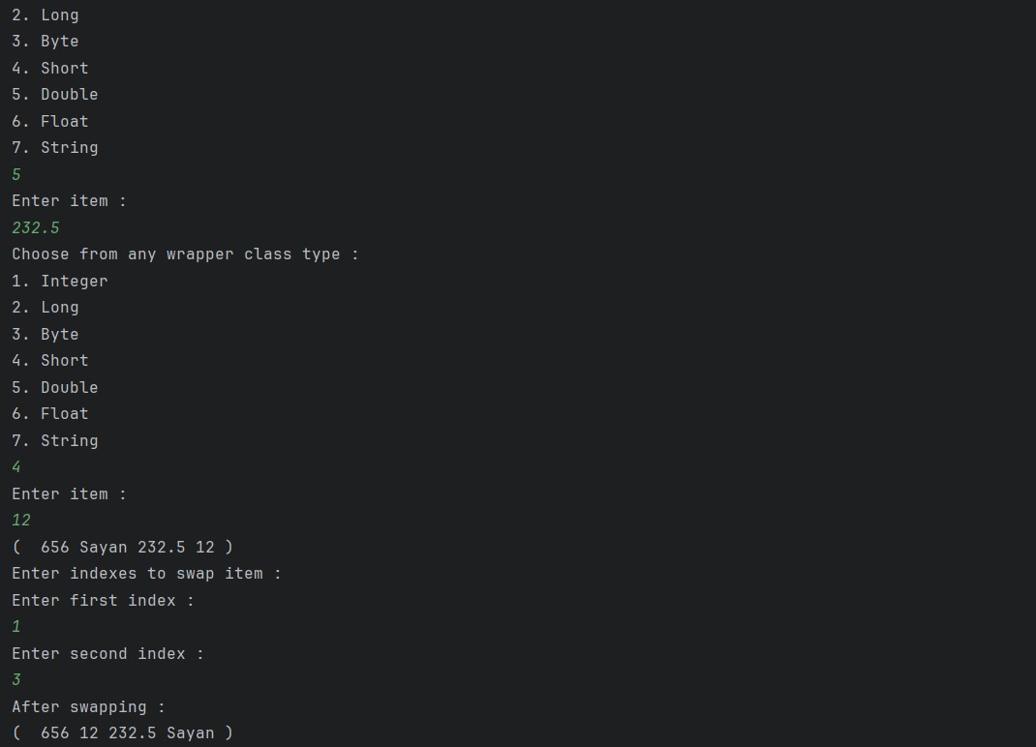

# Reflection API Use reflection to inspect a class's methods, fields, and constructors, and modify the access level of a private field, setting its value during runtime

|  |
| --- |
| package m5_core_java_programming.day_12; |
|  |
| /* |
| Reflection API Use reflection to inspect a class's methods, fields, and |
| constructors, |
| and modify the access level of a private field, setting its value during |
| runtime |
|  |
| */ |
| import java.lang.reflect.*; |
|  |
| class RefExample { |
| private int num1; |
| protected int num2; |
| public String name; |

|  |
| --- |
|  |
| private RefExample() { |
| this.num1 = 0; |
| this.num2 = 0; |
| this.name = "Default Name."; |
| } |
|  |
| public RefExample(int num1, int num2) { |
| this.num1 = num1; |
| this.num2 = num2; |
| this.name = "Default Name."; |
| } |
|  |
| public RefExample(int num1, int num2, String name) { |
| this.num1 = num1; |
| this.num2 = num2; |
| this.name = name; |
| } |
| public void publicMethod() { |
| System.*out*.println("I am public."); |
| } |
|  |
| private void privateMethod(String str) { |
| System.*out*.println("I am private."); |
| System.*out*.println("But they have invoked me with this value " + str); |
| } |
|  |
| protected void protectedMethod() { |
| System.*out*.println("I am protected."); |
| } |
|  |
| public int getNum1() { |
| return num1; |
| } |
|  |
| public void setNum1(int num1) { |
| this.num1 = num1; |
| } |
|  |
| public int getNum2() { |
| return num2; |
| } |
|  |
| public void setNum2(int num2) { |
| this.num2 = num2; |
| } |
|  |
| public String getName() { |

|  |
| --- |
| return name; |
| } |
|  |
| public void setName(String name) { |
| this.name = name; |
| } |
| } |
|  |
| public class Assignment_3 { |
| public static void main(String[] args) { |
| try { |
| Class c = |
| Class.*forName*("m5_core_java_programming.day_12.RefExample"); |
| System.*out*.println("All constructors of : " + c.getTypeName()); |
| Constructor[] constructor = c.getDeclaredConstructors(); |
| for (Constructor cons : constructor) { |
|  |
| System.*out*.println("----------------------------------------------------------" |
| + "\n" +  "Modifier : " + Modifier.*toString*(cons.getModifiers()) + |
| "\n" + |
| "Constructor Name : " + cons.getName() + "\n" + |
| "Parameter count : " + cons.getParameterCount() |
| ); |
| } |
|  |
| System.*out*.println("........................................................... |
| ..."); |
| System.*out*.println("All the methods of :" + c.getTypeName()); |
| Method[] method = c.getDeclaredMethods(); |
| for (Method meth : method) { |
|  |
| System.*out*.println("----------------------------------------------------------" |
| + "\n" + |
| "Modifier : " + Modifier.*toString*(meth.getModifiers()) + |
| "\n" + |
| "Method Name : " + meth.getName() + "\n" + |
| "Parameter count : " + meth.getParameterCount() + "\n" + |
| "Return type : " + meth.getReturnType() |
| ); |
| } |
|  |
| System.*out*.println("........................................................... |
| ..."); |
| System.*out*.println("All the Fields of :" + c.getTypeName()); |
| Field[] fields = c.getDeclaredFields(); |
| for (Field field : fields) { |
|  |
| System.*out*.println("----------------------------------------------------------" |
| + "\n" + |
| "Modifier : " + Modifier.*toString*(field.getModifiers()) |
| + "\n" + |
| "Field Name : " + field.getName() + "\n" + |
| "Field type : " + field.toGenericString() |
| ); |
| } |
|  |
| System.*out*.println("........................................................... |
| ..."); |
| System.*out*.println("Setting private privateMethod method to |
| public"); |
| Method privToPublic = c.getDeclaredMethod("privateMethod", |
| String.class); |
| privToPublic.setAccessible(true); |
| RefExample ref = new RefExample(1, 10); privToPublic.invoke(ref, "Set to Public"); |
|  |
| } catch (ClassNotFoundException e) { |
| throw new RuntimeException(e); |
| } catch (NoSuchMethodException e) { |
| throw new RuntimeException(e); |
| } catch (InvocationTargetException e) { |
| throw new RuntimeException(e); |
| } catch (IllegalAccessException e) { |
| throw new RuntimeException(e); |
| } |
| } |
| } |

# Output

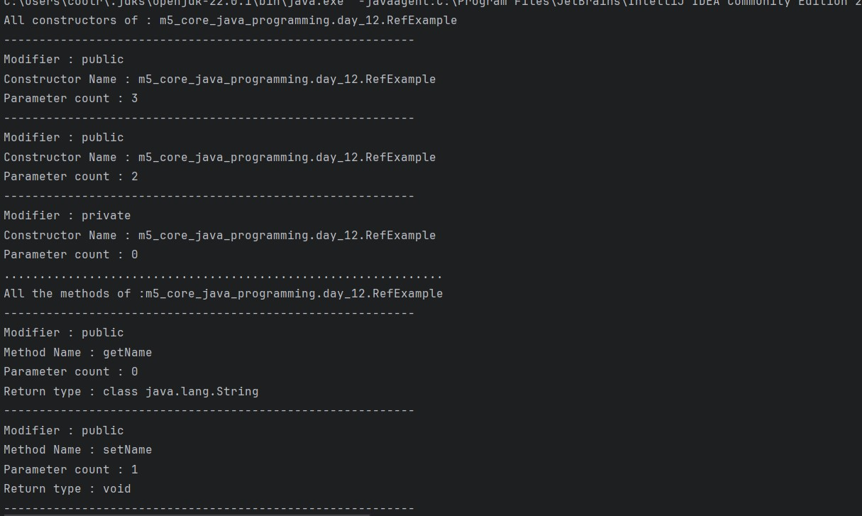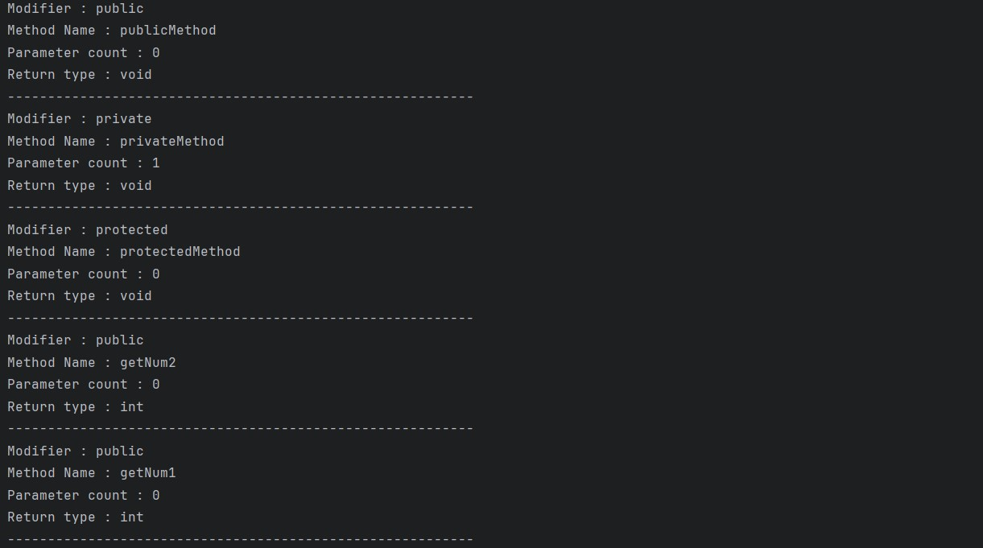

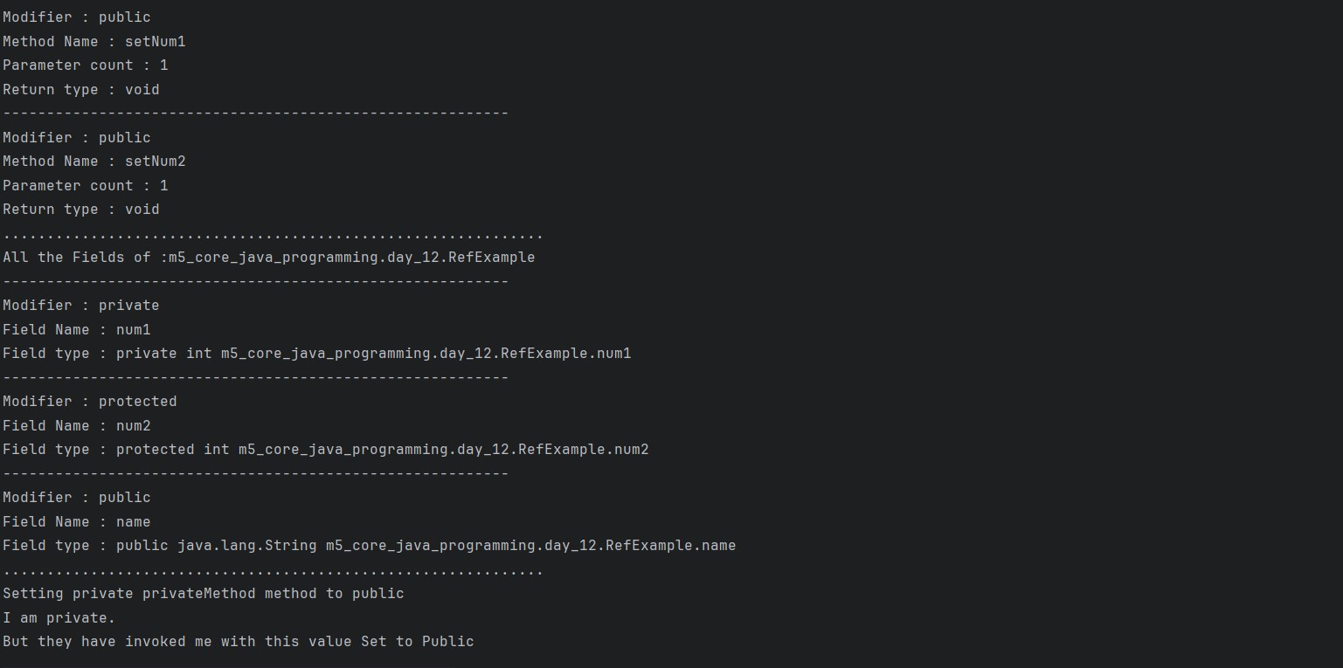

**4. Implement a Comparator for a Person class using a lambda expression, and sort a list of Person objects by their age.**

|  |
| --- |
| package m5_core_java_programming.day_12; |
|  |
| /* |
| Implement a Comparator for a Person class using a lambda expression, |
| and sort a list of Person objects by their age. |
| */ |
|  |
| import java.util.LinkedList; |
| import java.util.Scanner; |
| class Person { |
| private String name; |
| private int age; |
|  |
| public Person(String name, int age) { |
| this.name = name; |
| this.age = age; |
| } |
|  |
| public int getAge() { |
| return age; |
| } |
|  |
| public String getName() { |
| return name; |
| } |
|  |
| public void setName(String name) { |
| this.name = name; |
| } |
|  |
| public void setAge(int age) { |
| this.age = age; |
| } |
|  |
| @Override |
| public String toString() { |
| return "Person{" + |
| "name='" + name + '\'' + |
| ", age=" + age + |
| '}'; |
| } |
| } |
|  |
| public class Assignment_4 { |
| public static void main(String[] args) { |
| Scanner scan = new Scanner(System.*in*); |
| LinkedList<Person> ls = new LinkedList<Person>(); |
| System.*out*.println("Number of people to add : "); |
| int n = scan.nextInt(); |
| for (int i = 0; i < n; i++) { |
| System.*out*.println("Add name :"); |
| String name = scan.next(); |
| System.*out*.println("Add age :"); |
| int age = scan.nextInt(); |
| Person person = new Person(name, age); |
| ls.add(person); |
| } |
|  |
| System.*out*.println("Before Sorting :"); |
| System.*out*.println(ls); |
| System.*out*.println("After sorting :"); |
| ls.sort((a, b) -> a.getAge() - b.getAge()); |
| System.*out*.println(ls); |
|  |
| } |
| } |

# Output

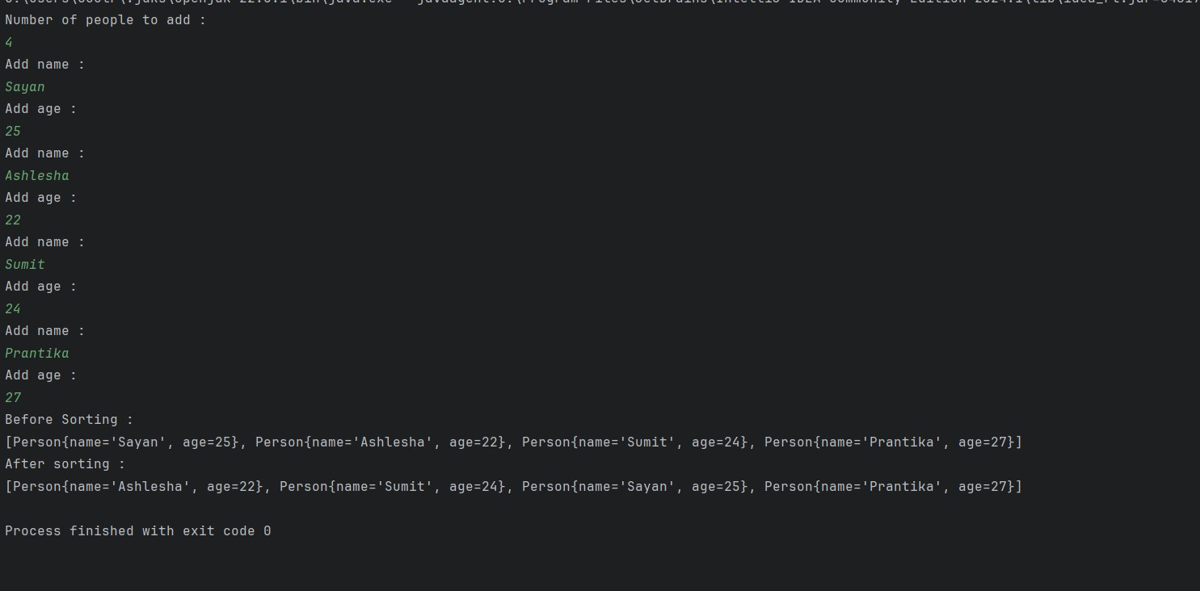

**5. Create a method that accepts functions as parameters using Predicate, Function, Consumer, and Supplier interfaces to operate on a Person object.**

|  |
| --- |
| package m5_core_java_programming.day_12; |
|  |
| /* |
| Create a method that accepts functions as parameters using Predicate, |
| Function, Consumer, and Supplier interfaces to operate on a Person object. |
| */ |
|  |
| import java.util.Scanner; |
| import java.util.function.Consumer; |
| import java.util.function.Function; |
| import java.util.function.Predicate; |
| import java.util.function.Supplier; |
|  |
| class SpecialFunction { |
| public static boolean predicate(Predicate<Person> p, Person person) { |
| return p.test(person); |
| } |
|  |
| public static Person supplier(Supplier<Person> s, String name, int age) { return s.get(); |
| } |
|  |
| public static int function(Function<Person, Integer> f, Person person) { |
| return f.apply(person); |
| } |

|  |
| --- |
|  |
| public static void consumer(Consumer<Person> c, Person person) { |
| c.accept(person); |
| } |
| } |
|  |
| public class Assignment_5 { |
|  |
| public static void main(String[] args) { |
| Scanner scan = new Scanner(System.*in*); |
| System.*out*.println("Creating a person object :"); |
| System.*out*.println("Enter name :"); |
| String name = scan.next(); |
| System.*out*.println("Enter age :"); |
| int age = scan.nextInt(); |
| Person person = new Person(name, age); |
|  |
| System.*out*.println("___________________________________________________________ |
| __________________");  System.*out*.println("Calling predicate functional interface :"); |
| Predicate<Person> p = (Person per) -> per.getAge() > 18; |
| System.*out*.println("This Predicate if the person is adult " + |
| SpecialFunction.*predicate*(p, person)); |
|  |
| System.*out*.println("___________________________________________________________ |
| __________________"); |
| System.*out*.println("Calling supplier functional interface :"); |
| System.*out*.println("Enter name :"); |
| name = scan.next(); |
| System.*out*.println("Enter age :"); |
| age = scan.nextInt(); |
| String finalName = name; |
| int finalAge = age; |
| Supplier<Person> s = () -> new Person(finalName, finalAge); |
| person = SpecialFunction.*supplier*(s, finalName, finalAge); |
| System.*out*.println("This Supplier will create a new Person object " + |
| person); |
|  |
| System.*out*.println("___________________________________________________________ |
| __________________"); |
| System.*out*.println("Calling function functional interface :"); |
| Function<Person, Integer> f = (Person per) -> per.getAge(); |
| System.*out*.println("This Function will return the age of the person " + |
| SpecialFunction.*function*(f, person)); |
|  |
| System.*out*.println("___________________________________________________________ |
| __________________"); |
| System.*out*.println("Calling consumer functional interface :"); |
| System.*out*.println("Current Age of person " + person.getAge()); |

|  |
| --- |
| System.*out*.println("Enter new age :"); |
| age = scan.nextInt(); |
| int finalAge1 = age; |
| Consumer<Person> c = (Person per) -> per.setAge(finalAge1); |
| SpecialFunction.*consumer*(c, person); |
| System.*out*.println("This Consumer will set new age in the person object |
| " + person); |
| } |
| } |

# Output

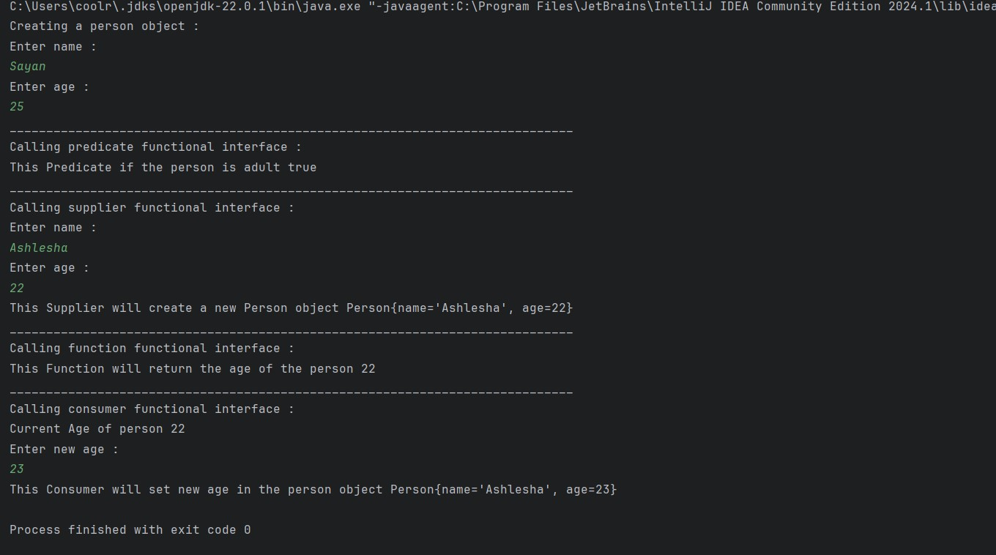

**Tools Used :**

IntelliJ IDE java version "1.8.0_411"

Java(TM) SE Runtime Environment (build 1.8.0_411-b09)

Java HotSpot(TM) Client VM (build 25.411-b09, mixed mode, sharing)